**[[Open](https://help.athenahealth.com/ohelp/Content/Features/aCom_Patient_Portal_A.htm?Highlight=User%20Guide%20-%20Patient%20Portal)Assisting patients with their Patient Portal accounts](https://help.athenahealth.com/ohelp/Content/Features/aCom_Patient_Portal_A.htm?Highlight=User%20Guide%20-%20Patient%20Portal)**

To assist a patient with the Patient Portal, you may need to know if the patient is new to your practice and has not yet registered. You may also need to know if the patient's provider allows appointment scheduling using the Patient Portal. You may need to provide the patient with the URL for your Patient Portal.

The following instructions help you walk patients through some of the more common tasks that they can perform on the Patient Portal.

**Note:** athenaOne assigns the "Prospective" status to a patient who first registers with your practice on the Patient Portal but has not yet checked in for an appointment. On the [Manage Prospective Patients](https://help.athenahealth.com/ohelp/Content/aCom_Manage_Prospective_Patients_PH.htm) page, you can view and manage all patients who are in Prospective status.

[**[Open](https://help.athenahealth.com/ohelp/Content/Features/aCom_Patient_Portal_A.htm?Highlight=User%20Guide%20-%20Patient%20Portal)Supported browsers for the Patient Portal**](https://help.athenahealth.com/ohelp/Content/Features/aCom_Patient_Portal_A.htm?Highlight=User%20Guide%20-%20Patient%20Portal)

To use the [Patient Portal](https://help.athenahealth.com/ohelp/Content/Features/aCom_Patient_Portal_A.htm?Highlight=User%20Guide%20-%20Patient%20Portal), patients must use a computer or mobile device with one of these supported browsers:

* Google Chrome
* Microsoft Edge (for Windows 7, Windows 8/8.1, Windows 10, and Windows 11)
* Mozilla Firefox
* Safari (for Apple devices only)

Patients who attempt to use an unsupported browser (such as Internet Explorer) to access the [Patient Portal](https://help.athenahealth.com/ohelp/Content/Features/aCom_Patient_Portal_A.htm?Highlight=User%20Guide%20-%20Patient%20Portal) receive a message with links to download a supported browser. If patients ask you about these messages, please encourage them to upgrade to a supported browser using the links displayed in the alerts.

**Note:** To use the **Log in to Portal as Patient** option on the [Quickview](https://help.athenahealth.com/ohelp/Content/Quickview_PH.htm), practice staff must also use a supported browser (not Internet Explorer).

[**[Open](https://help.athenahealth.com/ohelp/Content/Features/aCom_Patient_Portal_A.htm?Highlight=User%20Guide%20-%20Patient%20Portal)To create a Patient Portal account from an email invitation or notification**](https://help.athenahealth.com/ohelp/Content/Features/aCom_Patient_Portal_A.htm?Highlight=User%20Guide%20-%20Patient%20Portal)

**Important:** To comply with the Children's Online Privacy Protection Act (COPPA), patients under the age of 13 cannot create self-registered Patient Portal accounts, and you cannot register or invite new Patient Portal users under the age of 13. For patients under 13 years old, we recommend that you set up a family access account for a parent or other caregiver to access the patient's health and billing information through the Patient Portal.

Patients and family members can register for the Patient Portal in several ways:

* Patient Portal email invitation
* Notification email, such as an appointment reminder or notice that a lab result has been published to the Patient Portal
* During an office visit (see [To register a patient for the Patient Portal or Patient Information Center in the office](https://help.athenahealth.com/ohelp/Content/Breakout/Bcom_To_register_a_patient_for_the_Patient_Portal_or_PIC_in_the_office_B.htm))

Patients and family members are prompted to create an athenahealth account when they register for the Patient Portal.

Following are instructions for a patient or family member who is creating a Patient Portal account for the first time from an email invitation or an athenaCommunicator notification email.

1. Click the Patient Portal link in the email.  
   In a Patient Portal invitation email, the link is Create My Account. In a lab result email, the link is View Results.  
   The Create your new password page appears.  
   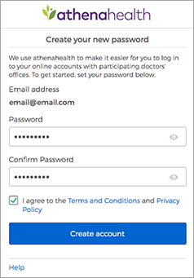
2. Confirm your email address and enter your password twice. After you review the Terms and Conditions and the Privacy Policy, check the box and click Create account.  
     
   You are prompted to select a security option to protect your account. This one-time setup enables you to confirm your identity in the future if you forget your password.  
   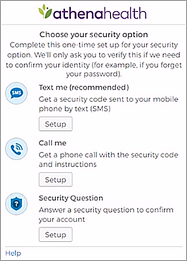
3. Select a security option and then click the Setup button below that option.
   * **Text me (recommended)** — Receive a verification code by text message.
   * **Call me** — Receive a verification code by phone call.  
     **Note:** Select this option if you entered the number of a landline phone.
   * **Security Question** — Select a security question from a list of questions.

**Note for practice users:** If the patient or family member selects phone verification (text or phone call), the phone number entered here is managed independently from the patient phone of record found on the [Quickview](https://help.athenahealth.com/ohelp/Content/Quickview_PH.htm) and [Patient Registration](https://help.athenahealth.com/ohelp/Content/Patient_Registration_PH.htm) pages.

1. If you selected **Text me** or **Call me**:
   * Enter your phone number and then click Send code (for text message) or Call (for phone call).  
     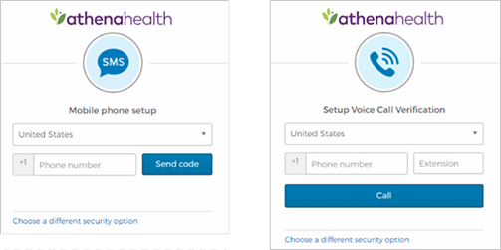  
     The verification code is sent to your phone.
   * Enter the verification code you received by text message or phone call, and then click Verify.  
     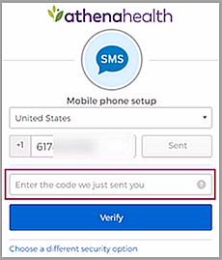
2. If you selected **Security Question**, select a question from the list, enter the answer, and then click Save.  
   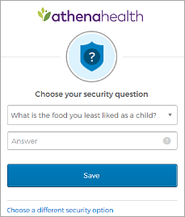  
   **Important:** If you enter any spaces or special characters (such as punctuation marks or underscores) in your answer, you will need to enter the same spaces and special characters in the future. The athenahealth account does not distinguish uppercase letters from lowercase letters.
3. If you set up a security question, or if you entered a recovery phone number that differs from the phone number in your patient record, you must verify access to the phone number on file with your healthcare provider.  
   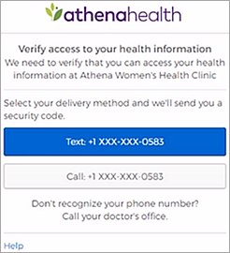  
   **Note for practice users:** If the user is the patient, the phone number of record is the phone number in the patient's [Quickview](https://help.athenahealth.com/ohelp/Content/Quickview_PH.htm). If the user is not the patient, the phone number is recorded on the [Portal Accounts](https://help.athenahealth.com/ohelp/Content/aCom_Portal_Accounts_PH.htm) page in the entry for the patient.
   * Select **Text** or **Call** to receive a verification code at the phone number displayed in the message.
   * Enter the verification code you received by text message or phone call, and then click Verify.  
     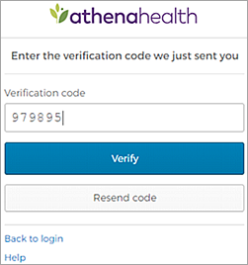
4. If you initiated your Patient Portal registration from a lab result email or during the online check-in workflow, you may see the Choose your patient relationship page. This page asks whether you are the patient or another person (family member or guardian) who manages the patient's account.  
   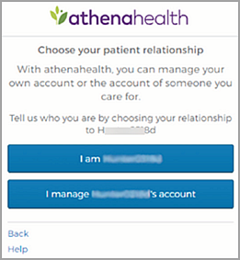
5. Click I am <patient_name> or I manage <patient_name>'s account.
6. If you click I manage <patient_name>'s account, you must enter your name, email address, and date of birth. This information is associated with your athenahealth account.  
   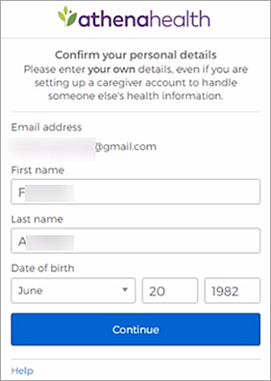
7. Click Continue.  
   A confirmation page appears.
8. On the confirmation page, click Continue.  
   The home page of your Patient Portal appears.  
   **Note:** When you log on to the Patient Portal in the future, you will need to enter only your email address and password.

[**[Open](https://help.athenahealth.com/ohelp/Content/Features/aCom_Patient_Portal_A.htm?Highlight=User%20Guide%20-%20Patient%20Portal)Instructions for patients to send a message with attachments**](https://help.athenahealth.com/ohelp/Content/Features/aCom_Patient_Portal_A.htm?Highlight=User%20Guide%20-%20Patient%20Portal)

**Important:** Tell your patients not to send any credit card information in the messages they send from the [Patient Portal](https://help.athenahealth.com/ohelp/Content/Features/aCom_Patient_Portal_A.htm?Highlight=User%20Guide%20-%20Patient%20Portal). Credit card information includes images of credit cards and credit card data entered as text.

1. On your desktop or laptop computer, log on to the [Patient Portal](https://help.athenahealth.com/ohelp/Content/Features/aCom_Patient_Portal_A.htm?Highlight=User%20Guide%20-%20Patient%20Portal).  
   The Patient Portal home page opens.  
   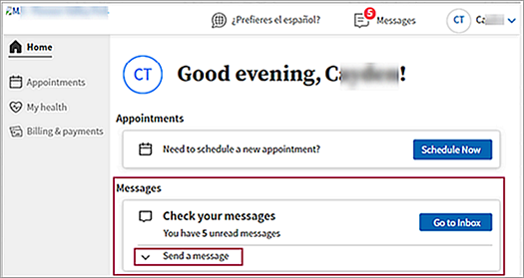
2. Scroll down to the Messages section of the home page.  
   **Important:** To attach a file to a message you are sending a provider, you must create the message from the Patient Portal home page. You can create and send a message without an attachment from the Messages page (access the Messages page by clicking the Messages icon at the top of the home page).  
   https://help.athenahealth.com/ohelp/Content/Resources/Images/PP_Messages_icon_new_GUI.png
3. If the message fields (**Provider**, **Subject**, etc.) do not appear, click **Send a message** to display them.  
   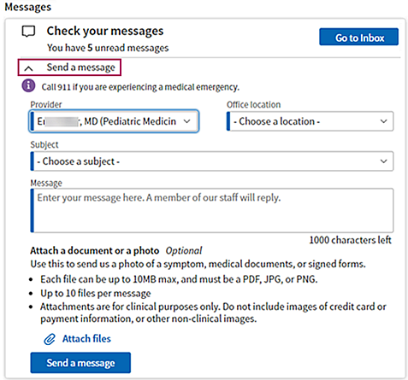
4. **Provider** — Select the provider to whom you are sending the message. The list includes providers that you've seen in the past.  
   **Note:** The **Office staff** option appears in the list only when the **Provider-based message routing** option is disabled on the [Portal Settings](https://help.athenahealth.com/ohelp/Content/aCom_Portal_Settings_PH.htm) page.
5. **Office location** — Select the location for the provider you selected. The options in the **Office location** list are the departments that the provider works in.  
   **Note:** This field is used to route the message to the appropriate [Clinical Inbox](https://help.athenahealth.com/ohelp/Content/C_Clinical_Inbox_PH.htm).
6. **Subject** — Select the subject of the message from the list, for example **Medical question** or **Appointments and scheduling**.
7. **Message** — Enter a detailed message (up to 1000 characters).
8. If you want to send the provider a file attachment:
   1. Click Attach files.
   2. Select the appropriate file from your browser or photo library.  
      **Note:** If you attach the wrong file, delete it before you send the message by clicking the X next to the file name.
   3. To send more than one file, click Attach files again. You can attach as many as 10 files.  
      **Note:** You must attach each file individually.  
      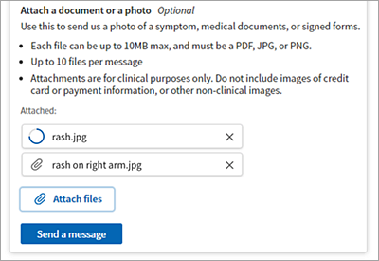
9. Click Send message.  
   The message is routed to the appropriate provider's [Clinical Inbox](https://help.athenahealth.com/ohelp/Content/C_Clinical_Inbox_PH.htm).
10. [[Open](https://help.athenahealth.com/ohelp/Content/Features/aCom_Patient_Portal_Quick_Reference_new_GUI_A.htm?Highlight=patient%20portal%20what%20patients%20see)**My Profile page**](https://help.athenahealth.com/ohelp/Content/Features/aCom_Patient_Portal_Quick_Reference_new_GUI_A.htm?Highlight=patient%20portal%20what%20patients%20see)
12. To access patient profile information, click the arrow next to your name at the top of the [Patient Portal](https://help.athenahealth.com/ohelp/Content/Features/aCom_Patient_Portal_A.htm) and select **My profile** from the menu.
13. 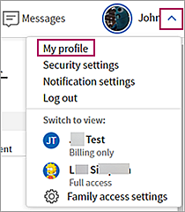

To access another family member or sibling’s profile information, click the arrow next to your name at the top of the Patient Portal, then listed under Switch to View choose the name of the profile you would like to view.